**SIMULATING FUSION PLASMAS IN MAGNETIC MIRRORS & TOKAMAKS**

Chee Xin Yi Hilary1, Yin Yue1, Liow Yi Yin Chloe1

Mentor: Dr Lee Choon Keat Paul2

1Raffles Girls’ School, 2 Braddell Rise, Singapore 318871

2Natural Sciences and Science Education, National Institute of Education, 1 Nanyang Walk, Singapore 637616

### **ABSTRACT**

Nuclear fusion is a highly promising source of clean energy, harnessing the energy stored within atomic nuclei, and has been proposed as a viable propulsion system for space exploration, enabling mankind to explore the Universe faster and further. Fusion conditions can be optimised by numerically simulating plasma. In this study, simplified C++ Particle-in-Cell (PIC) codes to simulate magnetic confinement and Deuterium-Tritium fusion in a magnetic mirror and a tokamak were produced. Parameters investigated are initial temperature, plasma densities and external magnetic field strength, and results are verified with observations of predicted phenomena. External magnetic fields have negligible impact on fusion species confinement at the timescales studied, while electron confinement plateaus at 5 T. Fusion cross-sections increase with plasma temperature, but approached a plateau beyond 100 keV. A cautious balance must be struck between plasma density, plasma temperature and fusion rate: high densities above 1025 m-3 lead to rapid loss of confinement, causing temperatures to plunge and fusion to stall.

### **INTRODUCTION**

Plasma fusion is under extensive research as the green energy of the future, fuelled by the depletion of existing energy resources. Fusion propulsion has been proposed as an alternative energy source for space exploration, enabling mankind to explore the cosmos more rapidly and efficiently, as opposed to chemical propulsion systems.[1][2]

Fusion plasma is an overall electrically neutral mixture of positively- and negatively-charged ions and electrons. It is characterised by its temperature (*Ti*), plasma density (*ni*) and fusion species (Table 1). *Ti*, is a measure of the kinetic energy, and hence, velocities of the particles. At high temperatures , nuclei have sufficient kinetic energy to overcome the Coulomb barrier and approach one another close enough for the strong nuclear force to dominate. However, if *Ti* is too great, particles cross the fusion radius more rapidly, decreasing opportunities for fusion to occur.

An optimum *ni* has to be struck: if it’s too low, the rate of collisions and thus energy generation is low, but when densities increase above an optimum threshold, energy loss via radiation becomes dominant.

For species type, Deuterium-Tritium (D-T) fusion is the most efficient (1), and is a common fuel in fusion reactors[3].

*(1)*

| **Parameter** | **Simulated range** | **Literature range[3]** |
| --- | --- | --- |
| Plasma temperature, *Ti* | 1-10 KeV | 4-10 KeV |
| Fusion species density, *ni* | 105 - 1016 m3 | 1020 m3 (ITER) |
| Fusion species | 50-50 Deuterium-Tritium (D-T) | D-D, D-He3, T-T, T-He3 |
| External magnetic fields | 0.01 - 10 Teslas | 0.001 - 10 Teslas |

*Table 1: Comparison of simulated plasma parameters compared to typical empirical values.*

The fusion cross-section (σ), i.e. the probability of a fusion reaction, is another important plasma parameter which increases as temperature increases. The reaction rate, $\underline{σv}$ is the predicted number of fusions per volume per unit time, and follows a similar trend (Figure 13)[4].

The aforementioned parameters can be summarised by the triple product for D-T fusion[5], estimating the necessary conditions for net energy gain from fusion

$n_{i}T_{i}τ_{E} ≥5 ×{10}^{21}$*(2)*

To sustain high levels of fusion for extended periods, **magnetic confinement** is commonly investigated. The motion of charged particles is strongly influenced by electric and magnetic fields, trapping particles, preventing energy loss and maintaining high densities for fusion.

One of the earliest, and simplest proposed confinement designs was the **magnetic mirror** (Figure 1, left). This cylindrical-shaped reactor confines plasma by “reflecting” escaping plasma particles back inside with strong magnetic fields at the ends. The magnetic moment of a charged particle (2) , describing its motion in a background magnetic field, is constant when external magnetic fields (B) evolve slowly, as is the case here.

$μ=\frac{mv_{⊥}^{2}}{2B}$*(3)*

When a plasma particle approaches the coils, B increases. However, since $μ$ is constant, its velocity perpendicular to the magnetic field must also increase. By conservation of energy,

$\frac{d}{dt}(\frac{1}{2}mv_{||}^{2}+\frac{1}{2}mv_{⊥}^{2})=0$*(4)*

implying that the particle’s parallel velocity decreases, slowing its escape. The particle is successfully deflected back into the reactor when its total kinetic energy is less than $μB$.

Although the fastest electrons and ions can still escape from the mirror ends, it is a highly flexible configuration and numerous modifications have been proposed[6].

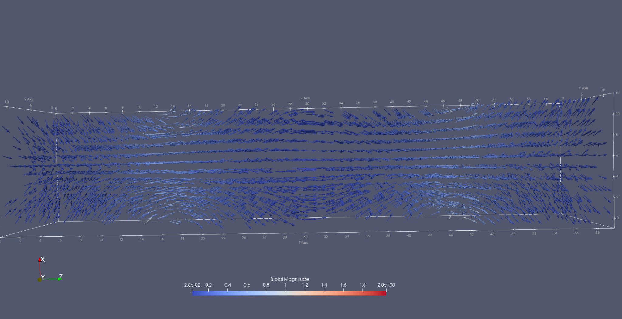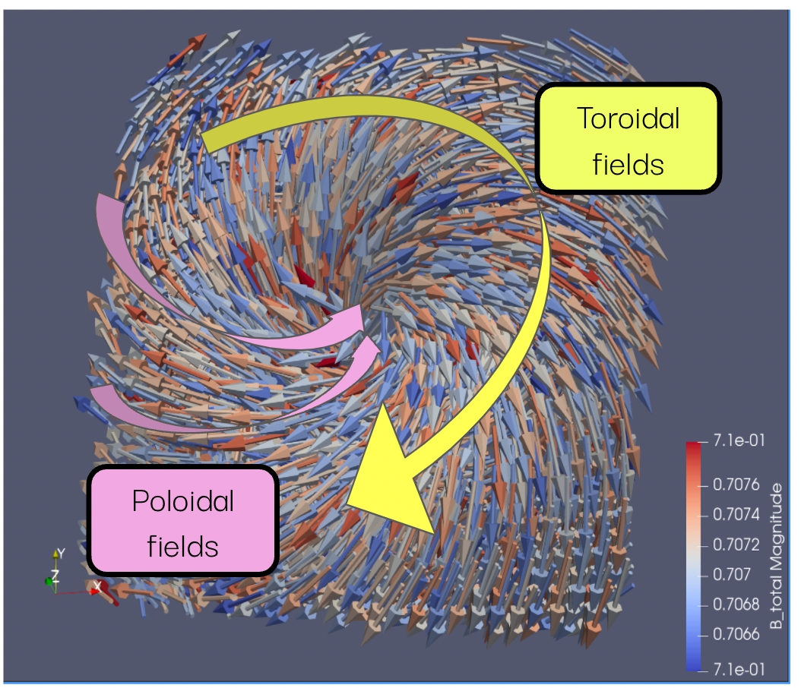

*Figure 1: (left) Magnetic field (in Teslas) produced by current coils in a simple magnetic mirror. (right) Calculated combined toroidal and poloidal fields in a tokamak.*

In recent years, much research has focused on **tokamaks,** most notably the joint ITER project[7]. Tokamak fields (Figure 1, right) are induced by the internal plasma current and the external toroidal and poloidal coils. With only a centre solenoid, although particles are prevented from escaping through the sides by circling magnetic fields in a z-pinch, particles are still able to escape through the ends. By bending the cylinder into a torus and joining the 2 ends together, such that the z-direction fields run toroidally, the problem of end losses is solved. The problem of plasma instabilities still exist.

Charged particles in a curved magnetic field experience curvature drift. A confinement system with only the toroidal field will cause the particles to continuously drift out of the plane of the curved fields where drift velocity is given by (5). Thus, both fields are needed so particles spiral around the reactor.

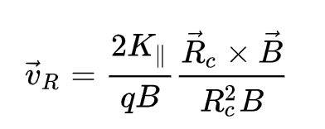 *(5)*

The two most common methods used to model plasmas are: magnetohydrodynamics (MHD), which models plasma as a fluid, and the Particle-in-Cell (PIC) approach[8][9], in which "superparticles'' interact in a 3D grid where fields are discretised upon (Figure 14). “Superparticles'' represent a larger number of plasma particles, enabling one to simulate higher plasma densities with limited resources.

Unfortunately, many plasma simulations are highly computational expensive, requiring long runtimes due to small timesteps, and extensive resources, making them inaccessible. Thus, in this study we produce and run a simplified PIC code in C++ that captures the essential physics of deuterium-tritium fusion plasma in a magnetic mirror and tokamak that can be run on a laptop, investigating the effect of external magnetic fields, plasma density and initial temperature.

### **MATERIALS AND METHODS**

In producing our program, the Particle-in-Cell method was chosen as the number of assumptions made in the physical model is reduced to the minimum. It can simulate high-dimensional cases and tackle complicated atomic and plasma-surface interactions[10].

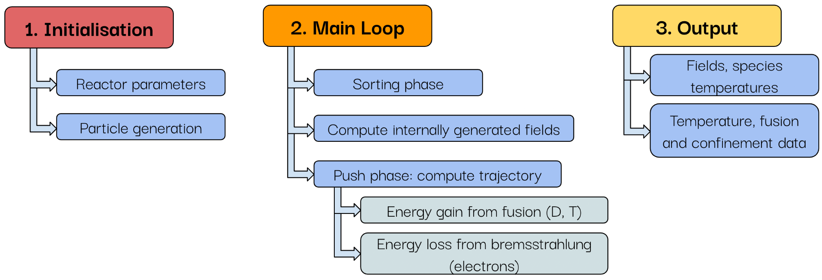

*Figure 2: Three stages of the PIC code produced.*

#### **Magnetic and Electric fields**

Internal magnetic fields are generated by the moving charged particles. This is described by the Biot-Savart law, where *dl* is the position of the particle.

***dB $= \frac{μ_{0}}{4π}\frac{I dl sinθ}{r^{2}}$*** *(6)*

Static external magnetic fields were built directly into the code for the *tokamak*. This was done by modelling both toroidal and poloidal fields as axisymmetric circular fields, which decrease with axial distance, about the reactor centre, and taking the vector sum of both in each cell.

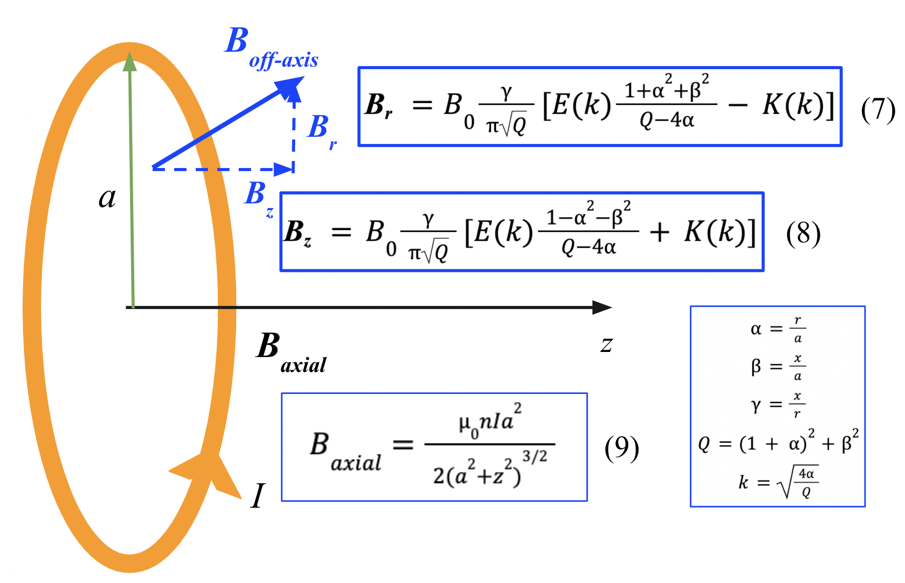

The external magnetic field in a *magnetic mirror* is the sum of the magnetic fields produced by current-carrying coils (Figure 3). Each of their magnetic fields can be broken down into two components: axial and nonaxial. The **axial** field (along z direction) is derived from (6), which for a closed circular loop is reduced to (7). The **nonaxial** field points in all 3 directions. The field along the axis reads as (8), while the radial field is (9), where *E(k)* and *K(k)* are complete elliptic integral functions of the first and second kind, respectively.

*Figure 3: Diagram illustrating magnetic field of a closed circular coil.*

Internally generated electric fields in each direction (*i, j, k*) due to uneven charge distribution were calculated with a modified Coulomb’s law for three dimensions[11]:

***E****i, j, k*  *(10)*

where *r* is the Euclidean distance between the cells compared and *q* is the difference in charge.

#### **Discretisation of Fields**

Particles interact with one another via self-generated magnetic and electric fields as calculated by (5) and (9). However, it is inefficient to compute the individual fields from each particle on every other particle. Instead, the field exerted by each cell (the vector sum of the charges of all particles within it) on every other cell was calculated, with distances computed from their centres. External magnetic fields were also discretised in this fashion.

#### **Choice of simulation timestep**

The timestep was dependent on the maximum expected magnetic field (*Bmax*), in order to ensure stability of the simulation (particles cross no more than one cell per timestep) and clearly capture the gyromotions. Higher magnetic fields required shorter timesteps no greater than the smallest plasma timescale, for which there are 4:

1. Cyclotron period: the time taken for an electron to complete one gyration within the magnetic field.

$t_{cyclotron} = \frac{2πm}{q_{e}B_{max}}$*(11)*

1. Plasma period: the shortest timescale over which perturbations in the plasma due to charge separation can propagate, given by the reciprocal of plasma frequency.

${t_{plasma}}^{-1}=\sqrt{\frac{n_{e}{q_{e}}^{2}}{mε_{0}}}/2π$*(12)*

1. The time taken for an electron travelling at the thermal velocity to cross half the reactor. The relationship between velocity and temperature is Boltzmann’s gas law, expressed as:

$v=\sqrt{\frac{{3k}_{B}T}{m}}$*(13)*

1. “Debye time”: time taken for an electron to cross the Debye length. The Debye length can be interpreted as the characteristic distance over which electric fields due to charge separation are damped.

$λ_{D} = \sqrt{\frac{ε_{0}k_{B}/q_{e}^{2}}{n_{e}/T_{e} + {Σ_{j}}_{}^{}Z_{j}^{2}n_{j}/T_{i} }}$*(14)*

In each timestep, particles were first sorted into the cell with the coordinates closest to their present position, then “pushed” to their next position based on their past positions, under the influence of externally and internally-generated electric and magnetic fields. We referenced code to compute particle trajectories in static magnetic fields[12], avoiding the artificial “input” of energy due to approximations in calculation purely based on particle velocities.

There are two main processes of energy change in the code: First, energy loss from electrons via bremsstrahlung. Bremsstrahlung is the loss of kinetic energy from electrons during rapid deceleration as they pass near heavier ions (which can be considered as stationary)[13].

*(15)*

Second, energy gain of fusion species from fusion. To reduce computations involved in direct particle-on-particle collisions and fusions, the total energy released from the predicted number of fusions occurring in each timestep was calculated and transferred to fusion species within the reactor. The total cross-section, σT, in barns (1 barn = 1024 cm3), was calculated according to (15), fitted with the Duane coefficients (An) corresponding to D-T fusion (Table 2)[14]. It is a function of *E*, the average temperature of fusion species in the reactor.

$σ_{T}(E) = \frac{A_{5} +{ [{(A_{4} - A_{3}E)}^{2} + 1]}^{-1} A_{2}}{E [exp(A_{1}E^{-\frac{1}{2}}) - 1]}$*(15)*

The “reaction rate”, $\underline{σv}$, was then computed according to (16) for low energy plasmas (E ⪅ 25 keV), and Table 3 for higher energy plasmas.[15]

*(16)*

Field configurations and particle trajectories were visualised on Paraview[16].

### **RESULTS**

#### **Physical Validation**

First, we validate the code based on expected physical phenomena. Confined particles gyrate along magnetic field lines (Figure 4) in a helical fashion. Particles gyrate with increased frequency in tighter helixes on approaching the coils, as predicted by the cyclotron period (11): the higher magnetic field leads to a smaller period and reduced gyroradius (17). 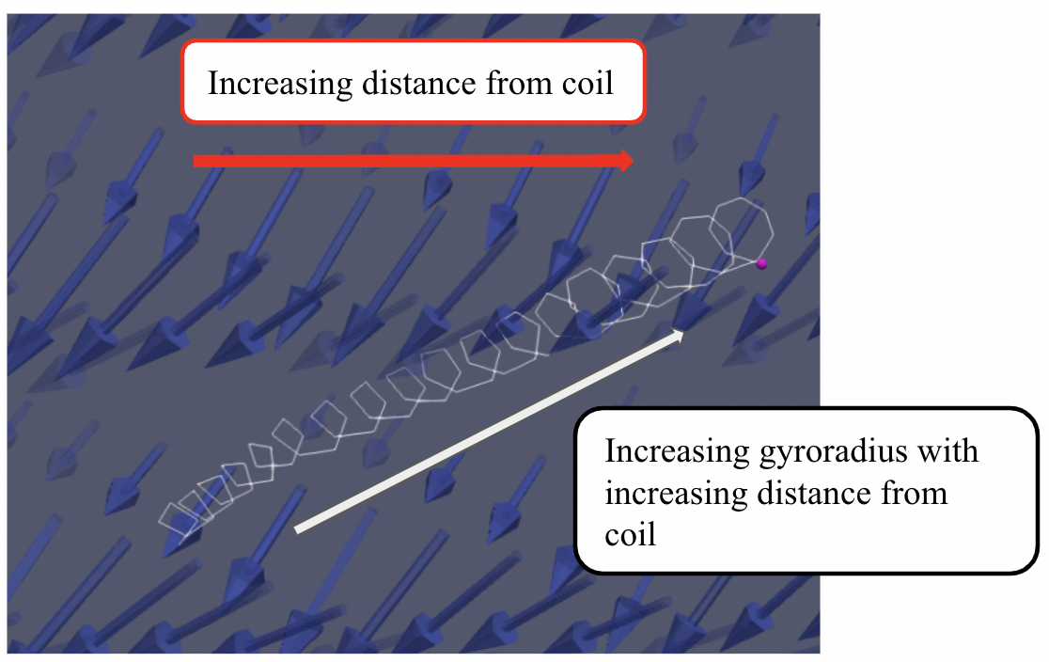

$r_{L}=\frac{mv}{\left|q\right|B}$*(17)*

*Figure 4: Electron gyrating along field lines.*

In the magnetic mirror, the deflection of escaping particles was indirectly observed from the eventual reduced particle density at regions close to the coils (Figure 5). It is observed that most of the losses are in the radial direction, as seen from the stationary row of electrons at the top and bottom of the reactor.

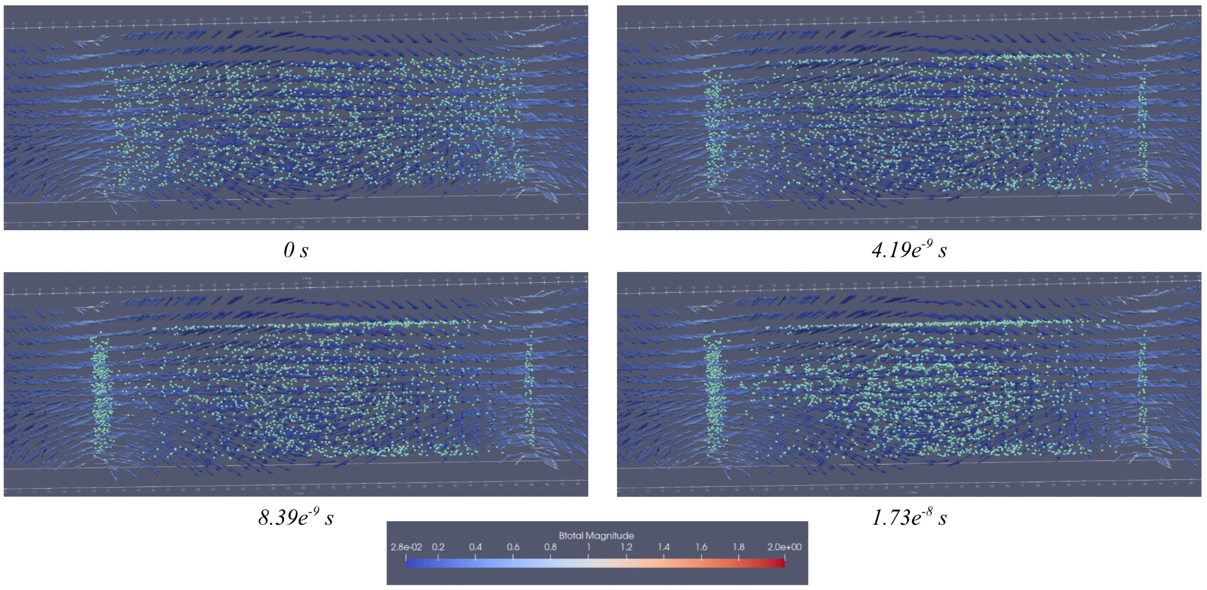

*Figure 5: Motion of electrons in magnetic mirror over time. Deuterons and tritons are not shown due to the small distance travelled and to reduce clutter.*

While in the tokamak, particles clearly show a curved trajectory around the reactor (Figure 6)

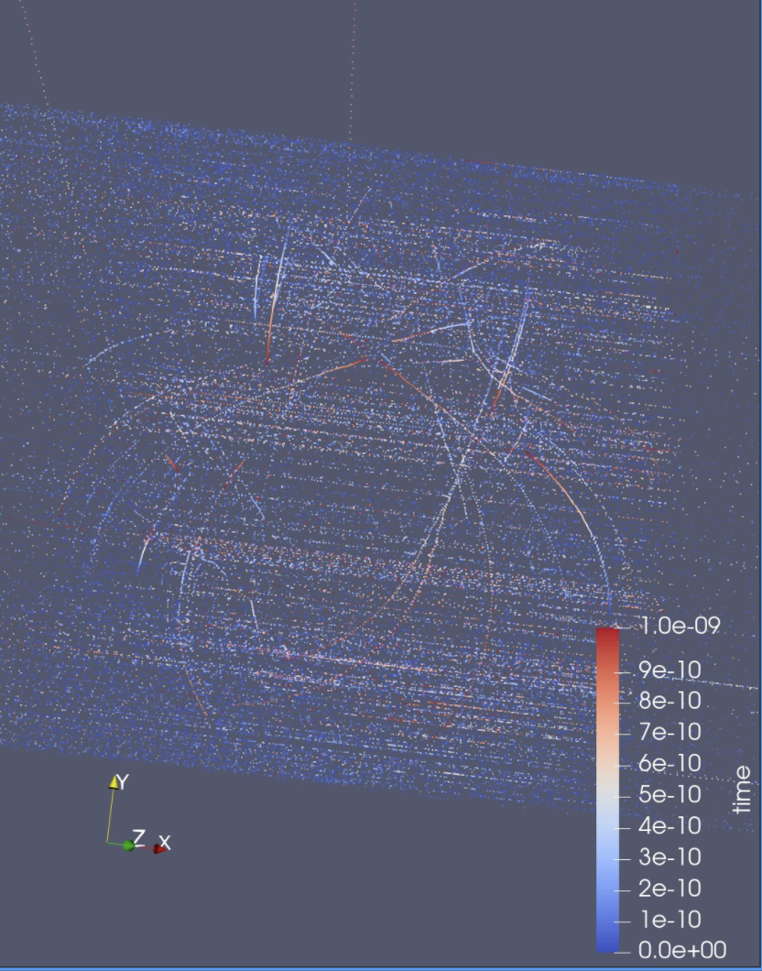

*Figure 6: Curved trajectories of plasma particles around the tokamak.*

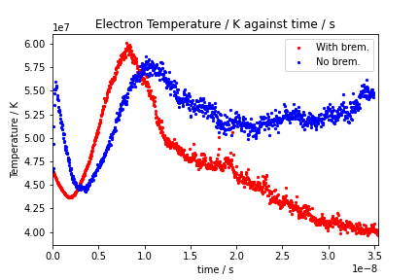

A comparison between plasma with and without bremsstrahlung was made. Bremsstrahlung contributes significant energy loss in the plasma, much more rapidly than energy loss due to escape of the fastest electrons from the plasma (Figure I 7).

*Figure 7: Comparison of electron temperatures simulated with and without brem(sstrahlung).*

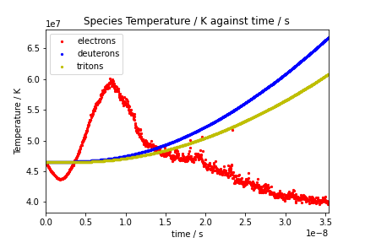

The temperature evolution of the plasma species reflects the energy change processes in the code (Figure 8): electrons lose energy due to bremsstrahlung, while deuterons and tritons gain energy due to fusion, albeit at a slower rate for tritons due to their greater mass.

*Figure 8: Species temperature over time.*

#### **Investigation into various parameters**

As the external magnetic field strength increases, confinement rate generally increases, but reaches a plateau at 5 T, in the confinement timescales studied (Figure 9). Since electrons have lower mass, they have higher thermal velocities, so more electrons than ions escape.

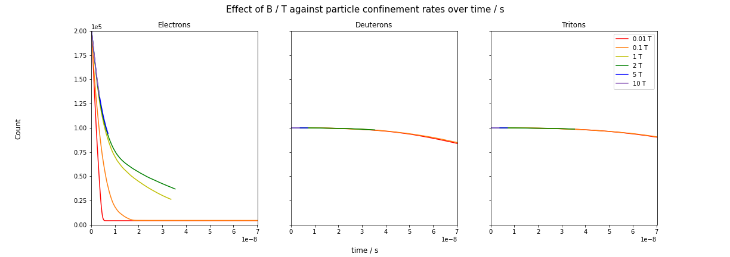

*Figure 9: Effect of external magnetic field strength on species confinement rates.*

Considering the scenario of a particle along the reactor midplane (halfway between coils), (18) defines a fixed “loss cone”: all particles satisfying (18) are successfully trapped.

$\frac{\left|v_{||}\right|}{\left|v_{⊥}\right|}<\sqrt{(\frac{B_{max}}{B_{min}}-1)}$*(18)*

As evident in Figure 8, higher magnetic fields prolong confinement by slowing the time taken for particles to escape. Electron loss rates decrease over time, as the loss of electrons results in an electrically positive plasma and the formation of a Debye sheath. This encourages positive ions to diffuse out but attracts the oppositely charged electrons back, slowing the rate of electron loss. For heavier deuterons and tritons, differences in confinement rates are not significant at these time scales.

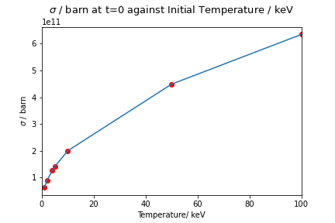

As temperature increases, fusion cross-sections also increase (Figure 10), increasing the fusion rate. Although the threshold at which fusion cross-section reaches its maximum before decreasing was not observed, the increase with temperature begins to slow from 20 keV onwards, evident from the decreasing gradient.

*Figure 10: Effect of initial temperature on fusion cross-section.*

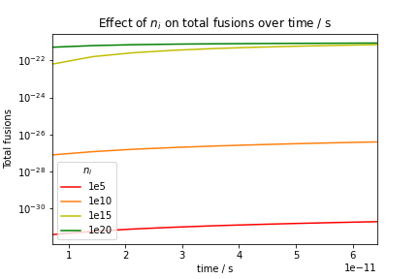

Amount of fusion that occurs increases when density increases (Figure 11). Opportunities for collisions between particles increase, increasing fusion rate. However, at higher densities beyond 1015 m-3, the increase in fusion rate plateaus. This is because with higher densities and higher fusion rates, more energy is also produced causing temperature to rise. Fusion species in the reactor are much more energetic, causing them to escape confinement much more rapidly, which explains the plateau.

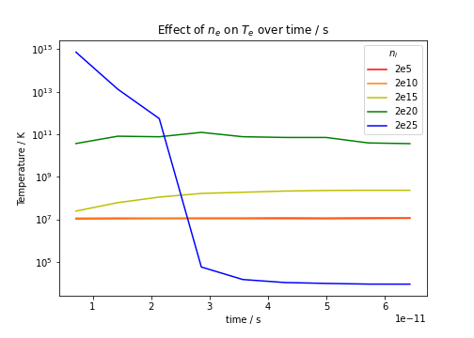

*Figure 11: Effect of ion density on total fusions.*

Similarly, temperature increases when particle density increases (Figure 12). At higher densities, more particles are accelerated by internally-generated electric fields, resulting in higher overall temperatures. However, above 1020 m-3, the temperature decreased drastically as particles were highly energetic and escaped rapidly.

*Figure 12: Effect of electron density on electron temperature.*

### **DISCUSSION**

It is concluded that external magnetic fields have little impact on fusion species confinement at the timescales studied, while electron confinement reaches a plateau at 5 T. Fusion cross-sections increase with plasma temperature, but appeared to reach a plateau beyond 100 keV. Similarly, for the same temperatures, fusion rates reach a plateau at plasma densities of 1020. A balance must be struck between plasma density and fusion rate: overly high densities lead to rapid loss of plasma particles, causing temperatures to plunge and fusion to stall.

Limitations of the code include the high superparticle-to-particle ratio of 1010 which may be unphysical, as clumping of particles implies electric charge concentrated at a small point, reducing accuracy during field computation. Still, plasma densities investigated were lower than actual fusion plasma, due to limited processing power, neglecting phenomena in high-density plasmas, such as higher internally generated current densities and fields and higher fusion rates.

Additionally, a curious increase in temperature was observed at early times of the simulation, and its root cause awaits identification. It is proposed to be a numerical artifact.

Finally, the simulation is highly simplified and does not take into account more complex phenomena. It assumes no collisions and subsequent resulting energy transfer between individual particles, with bremsstrahlung and fusion treated as macroscopic properties. This energy transfer is crucial at later times when temperature difference between species is more evident.

However, we would like to stress that this code aims to simulate the key processes in fusion plasma, and the modelling of these complex phenomena and particle-particle interactions would likely render the simulation less tractable.

In conclusion, this paper presents code simulating the basic properties and interactions of plasma in magnetic mirrors and tokamaks, that does not require large amounts of computing power. The code was verified with observations of gyration and reflection of particles on entering regions of higher magnetic fields. The effect of three parameters on confinement rates and fusion: external magnetic fields, initial temperature and plasma density were investigated. A crucial next step is to optimise the code, such as via parallel processing or electron speed-limited PIC[17], in order to run longer simulations and observe ion motion in the reactor, which was not captured in the time scales (1e-8 s) simulated. Internal magnetic fields could also be computed after every few timesteps, instead of in each one, since they are largely static.

With increasing interest in space travel, efficient, energy-dense propulsion systems determine how far, and how fast, mankind can travel. Future work could look into effectively integrating the magnetic mirror or tokamak in spacecraft propulsion systems, ushering in a new age of space exploration.

### **ACKNOWLEDGEMENTS**

We would like to thank the following people for all your support:

1. Mr Shih Chih Chuan from the Genome Institute of Singapore, for assisting us with programming issues.
2. Our teacher-in-charge Ms Cheong Szu Chuang for your unwavering support and experience with SMP teams.

The computational work for this study was partially performed on resources of the National Supercomputing Centre, Singapore ([https://www.nscc.sg](https://www.nscc.sg/)).

### **REFERENCES**

[1] Williams, C. H., Juhasz, A. J., Borowski, S. K., & Dudzinski, L. A. (2003). Space Propulsion via Spherical Torus Fusion Reactor. *Fusion Science and Technology*, *43*(1), 91–109. <https://doi.org/10.13182/fst03-a251>

[2] Razin, Y. S., Pajer, G., Breton, M., Ham, E., Mueller, J., Paluszek, M., Glasser, A. H., & Cohen, S. A. (2014). A direct fusion drive for rocket propulsion. Acta Astronautica, 105(1), 145–155.

[3] Haider, Q. (2019, January 9). Nuclear Fusion: Holy Grail of Energy. *Nuclear Fusion - One Noble Goal and a Variety of Scientific and Technological Challenges*. https://doi.org/10.5772/intechopen.82335

[4] Richardson, A. S. (2019, September). NRL Plasma Formulary.

[5] *Measuring Progress in Fusion Energy: The Triple Product*. (2019, December 19). Fusion Energy Base. <https://www.fusionenergybase.com/article/measuring-progress-in-fusion-energy-the-triple-products/>

[6] Post, R. F. (1987, August). Magnetic Mirror Fusion Systems; Characteristics and Distinctive Features. Lawrence Livermore National Laboratory.

[7] Summary of the ITER Final Design Report. (2001). ITER EDA Documentation Series, 22.

[8] Pous Xavier Sáez, M. Cela Espín José, &amp; Pascual, A. S. (2016). Particle-in-cell algorithms for plasma simulations on heterogeneous architectures (thesis). Universitat Politècnica de Catalunya, Barcelona.

[9] Birdsall, C. (1991). Particle-in-cell charged-particle simulations, plus Monte Carlo collisions with neutral atoms, PIC-MCC. IEEE Transactions on Plasma Science, 19(2), 65–85. <https://doi.org/10.1109/27.106800>

[10] Tskhakaya D. (2008) The Particle-in-Cell Method. In: Fehske H., Schneider R., Weiße A. (eds) Computational Many-Particle Physics. Lecture Notes in Physics, vol 739. Springer, Berlin, Heidelberg. https://doi.org/10.1007/978-3-540-74686-7_6

[11] Pedram, P. (2010). Modification of Coulomb’s law in closed spaces. American Journal of Physics, 78(4), 403–406. <https://doi.org/10.1119/1.3272020>

[12] F. Michel, Numerical integration of trajectories in static magnetic fields. OpenStax CNX. May 19, 2005 <http://cnx.org/contents/4442ead0-29b1-4962-add6-257bb94eee5c@2>.

[13] S. Glasstone and R. H. Lovberg, Controlled Thermonuclear Reactions (Van

Nostrand, New York, 1960), Chapt. 2.

[14] G. H. Miley, H. Towner and N. Ivich, Fusion Cross Section and Reactivities, Rept. COO-2218-17 (University of Illinois, Urbana, IL, 1974);

B. H. Duane, Fusion Cross Section Theory, in Rept. BNWL-1685 (Battelle

Pacific Northwest Laboratory, 1972)

[15] Richardson, A. S. (2019, September). NRL Plasma Formulary. <https://www.nrl.navy.mil/Portals/38/PDF%20Files/NRL_Formulary_2019.pdf?ver=p9F4Uq9wAtB0MPBwKYL9lw==>

[16] Ayachit, Utkarsh, The ParaView Guide: A Parallel Visualization Application, Kitware, 2015, ISBN 978-1930934306

[17] Werner, G. R., Jenkins, T. G., Chap, A. M., & Cary, J. R. (2018). Speeding up simulations by slowing down particles: Speed-limited particle-in-cell simulation. *Physics of Plasmas*, *25*(12), 123512. https://doi.org/10.1063/1.5061683

[18] Eite Tiesinga, Peter J. Mohr, David B. Newell, and Barry N. Taylor (2019), "The 2018 CODATA Recommended Values of the Fundamental Physical Constants" (Web Version 8.1). Database developed by J. Baker, M. Douma, and S. Kotochigova. Available at http://physics.nist.gov/constants, National Institute of Standards and Technology, Gaithersburg, MD 20899.

### **APPENDIX**

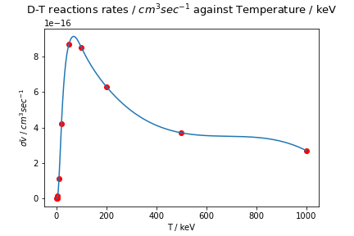

*Figure 13: Deuterium-Tritium reaction rates averaged over Maxwellian distributions.*

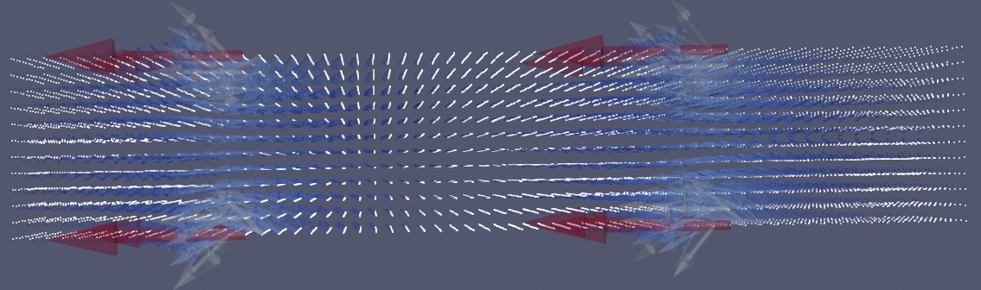

*Figure 14: PIC discretisation of fields (coloured) onto grid points (white).*

|  | A1 | A2 | A3 | A4 | A5 |
| --- | --- | --- | --- | --- | --- |
| D-T | 45.95 | 5.02 ✕ 10-4 | 1.368 ✕ 10-2 | 1.076 | 409 |

*Table 2: Duane coefficients corresponding to deuterium-tritium fusion[13].*

| Temperature / keV | $\underline{σv }$/ ${cm}^{3} \sec^{-1}$ |
| --- | --- |
| 1.0 | 5.5 ✕ 10-21 |
| 2.0 | 2.6 ✕ 10-19 |
| 5.0 | 1.3 ✕ 10-13 |
| 10.0 | 1.1 ✕ 10-16 |
| 50.0 | 8.7 ✕ 10-16 |
| 100.0 | 8.5 ✕ 10-16 |
| 500.0 | 3.7 ✕ 10-16 |
| 1000.0 | 2.7 ✕ 10-16 |

*Table 3: Reaction rates averaged over Maxwellian distributions.*

Variables

**B** = total magnetic field (broken down into *Bx, By, Bz*)

= permeability of free space, 1.25663706 × 10-6 m kg s-2 A-2

**E** = total electric field (broken down into *Ex, Ey, Ez*)

𝜀0 = permittivity of free space, 8.854 187 8128 x 10-12 F m-1

*k*B = Boltzmann constant, 8.617333262145×10−5 eV K-1

*qe* = elementary charge, 1.602 176 634 x 10-19 C

*Zj qe =* ionic charge of ion with charge *Zj*

σ = reaction cross-section

$\underline{σv}$ = average reaction rate

$μ$ = magnetic moment

*λ*D: Debye length

*Te, i*: temperature

*ne, i*: density of particle species

*\*all constants were taken from the 2018 CODATA database[17]*

*Table 4: List of variables used.*